

*A Bulgarian student passionate about programming, listening to music, exploring new places and meeting new people.*

*More of a tech guy but aware of the power User Experience has over users and their interaction with the tech product.*

Angel Hadzhiev

What did I do?

**Table of Contents**

iOS Week1 4

Storyboard App 5

FizzBuzz 6

Black Jack 7

Alphabet Soup 8

Absolute Sum 9

Arrest The Criminal 10

IXD Week1 11

Workshop Personas - Mobile Interaction Design 11

Smart Mobile Interaction Design Workshop 14

iOS Week2 16

Demo Navigation App 16

Bull’s Eye App 19

Player Ratings App 22

IXD Week2 27

Workshop Scenarios 27

Everyday Scenario - Me 28

Gold Platted Scenario - Me 28

Horror Scenario - Me 29

Ideal Scenario - Me 29

Worst Scenario - Me 30

My Persona (John) Everyday Scenario 30

My Persona (John) Ideal Scenario 31

My Persona (John) Horror Scenario 31

My Persona (John) Worst Scenario 32

MoSCoW 32

iOS Week3 33

PiratesList DemoApp 33

CoursesList App 34

RickAndMorty EpisodesList App 35

BikesList App 36

IXD Week3 37

iOS Week4 40

MapKit & Core Location App 40

Core Location 42

IXD Week4 42

User Testing Workshop 42

DUO app Week5 44

Week One

# **iOS Week1**



During the first week of Smart Mobile, we had an introduction from our teacher. We were told that during every Thursday and Friday there are different workshops where if we attend them, we can learn more both on the technical part and the design part(ixd).

I attended the workshop for iOS where the teacher introduced us to xCode. I learnt what the different components of a xCode project are such as ViewController, Storyboard and etc.

The teacher made a demo of soundboard application where I both learnt how to work with xCode and how to implement simple Swift code.

From there I implemented the same application and learnt how to improve the code so it can be more efficient.

## Storyboard App

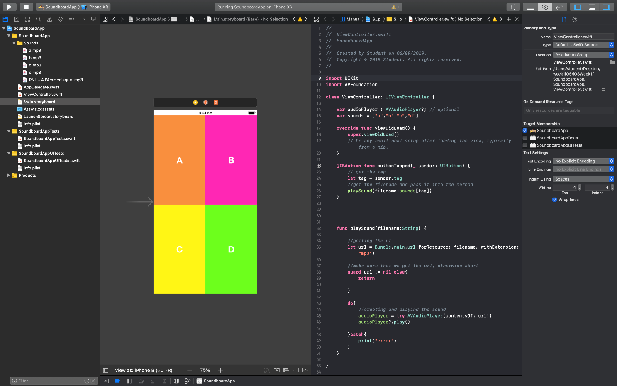

The application can be found in the following git repository: <https://git.fhict.nl/I378011/smindividualiosrepository.git>

## FizzBuzz

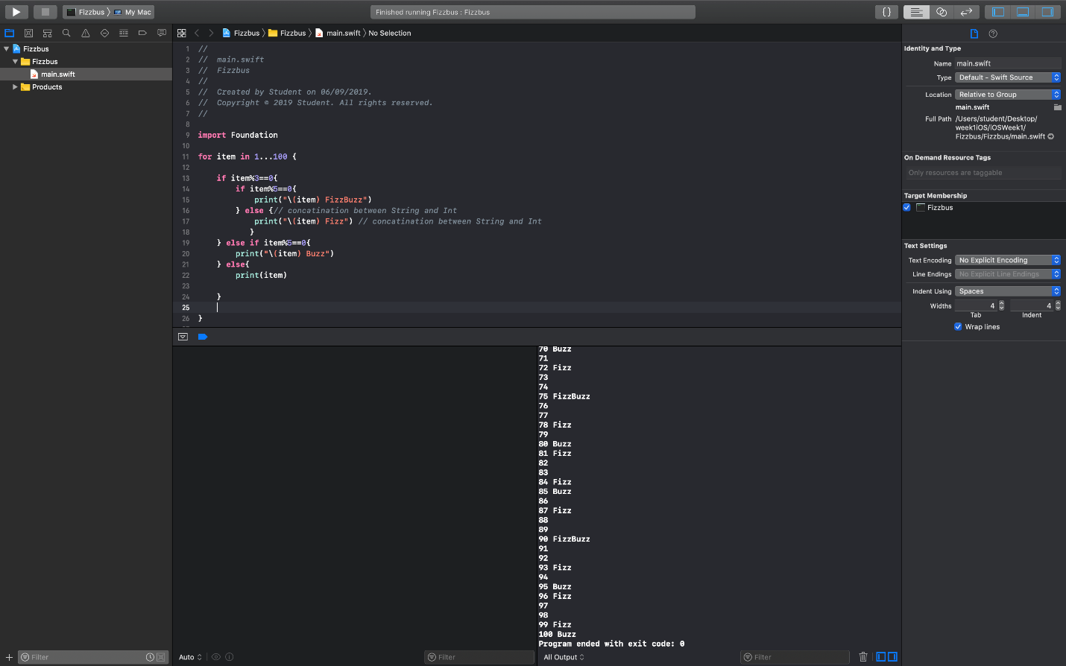

The application can be found in the following git repository: <https://git.fhict.nl/I378011/smindividualiosrepository.git>

## Black Jack

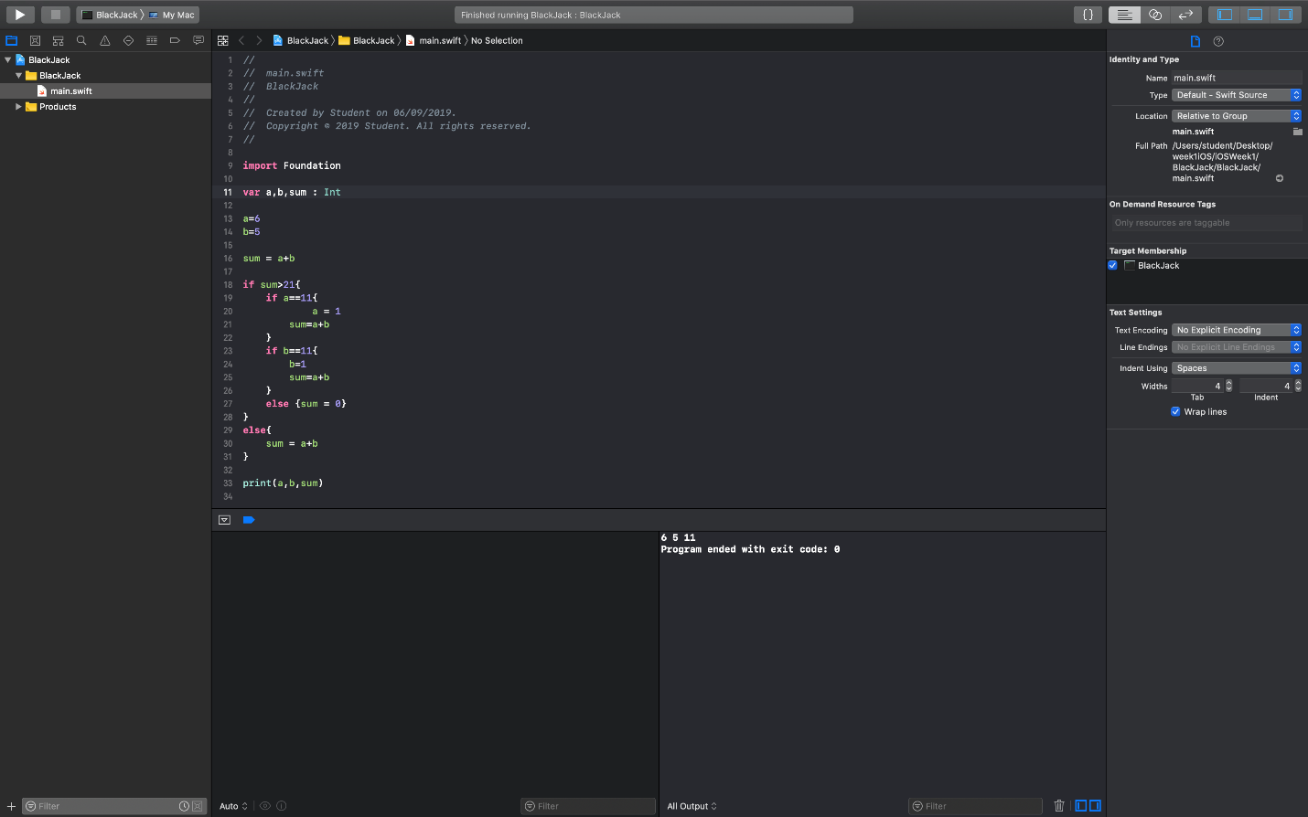

The application can be found in the following git repository:

<https://git.fhict.nl/I378011/smindividualiosrepository.git>

## Alphabet Soup

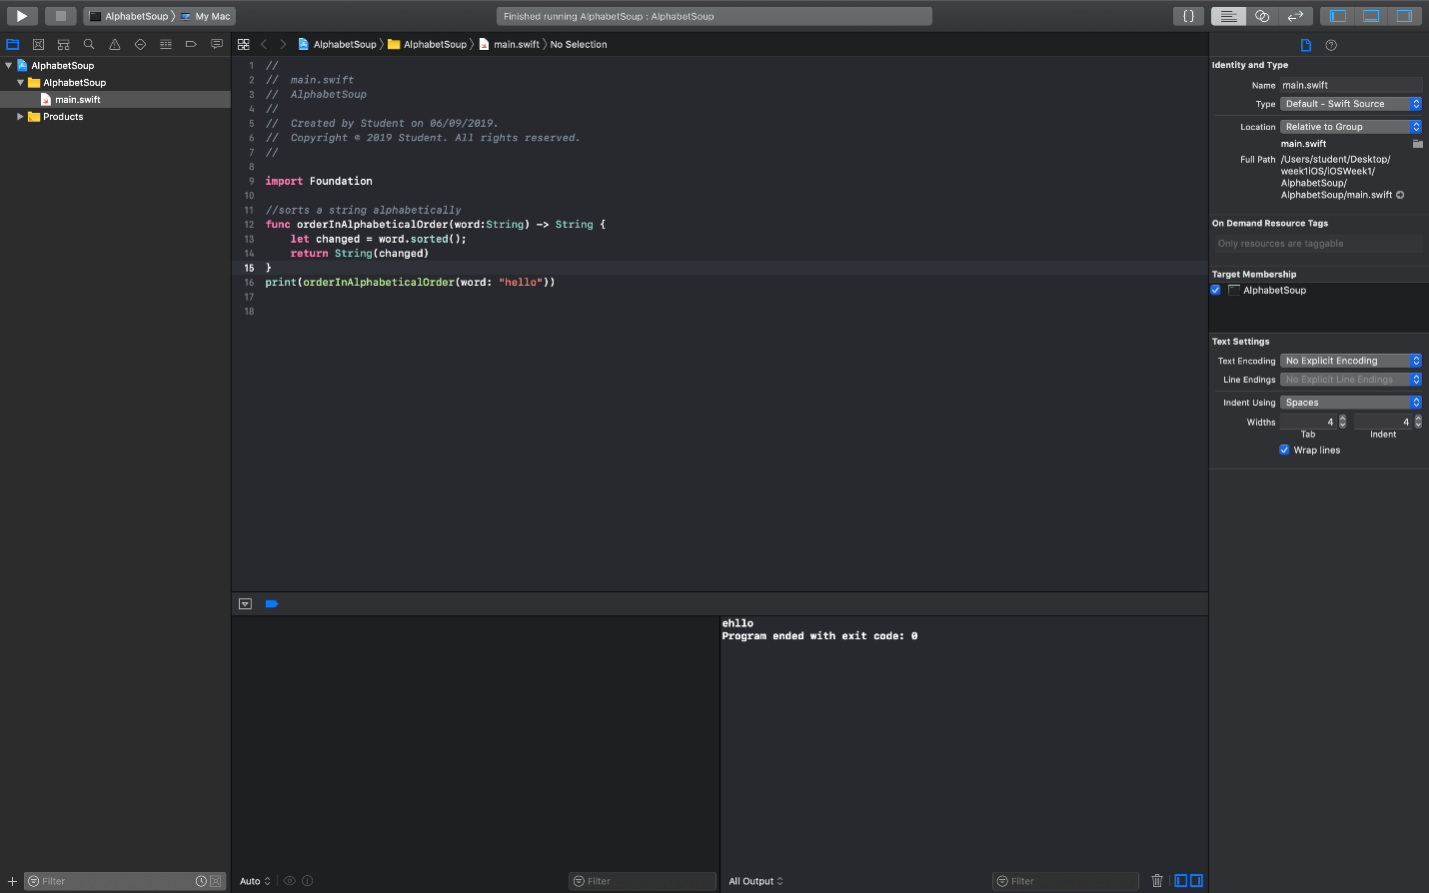

The application can be found in the following git repository:

<https://git.fhict.nl/I378011/smindividualiosrepository.git>

## Absolute Sum

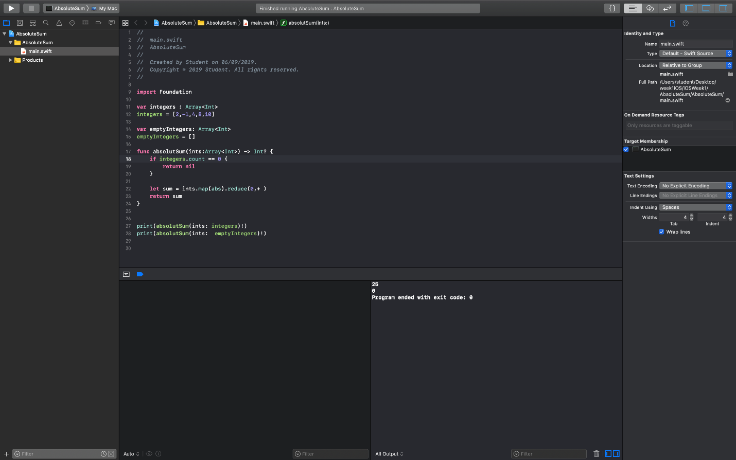

The application can be found in the following git repository:

<https://git.fhict.nl/I378011/smindividualiosrepository.git>

## Arrest The Criminal

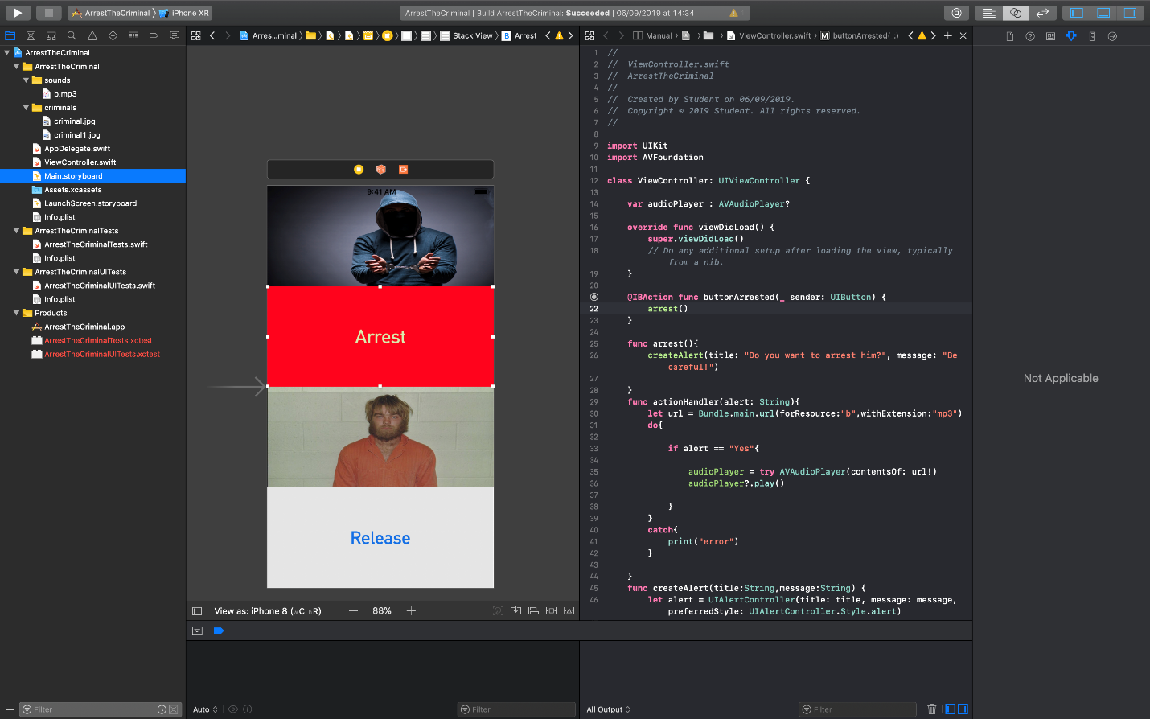

The application can be found in the following git repository:

<https://git.fhict.nl/I378011/smindividualiosrepository.git>

# **IXD Week1**

## Workshop Personas - Mobile Interaction Design



*Dodge Ram van*

#### Describe this customer - what characteristics define this user?

*use text, images from Google or make a sketch - 10 minutes*



***The way I see the user of this truck is that it is a male who perceives himself as an alpha male. Potentially a construction worker or something else related to hard work.***

***This person likes to show off with what he has and, in this way, to have his self-esteem high.***

***He is not too rich but has enough money to treat himself well.***

#### Create a persona – Stay-at-home dad using Spotify

***Who is he?***

***What is his main goal?***

***What stops him from achieving that goal?***



Hard Facts

*John is unemployed, father of two. His wife is the only one bringing money on the table so he takes care of the children. John is a stay-at-home dad. In the short moments he is not taking care of his children he is looking for a part time job so he can support his family.*

***Interests and Values***

*In high school has been part of a rock band and since then he likes to listen to rock. His favorite group is Queen.*

*John also likes reading books while being in the nature. He enjoys the sound of nature.*

*Nowadays, he really values his free time because his children take most of his time and the short time, he has for himself, he tries to use as much as possible.*

***Spotify Use***

*John really likes the way Spotify lets him enjoy music – all songs within an easy reach. Most of the time he listens to old rock songs, mostly songs of his favorite band Scorpions.*

*His main goal in using Spotify is to rest from the busy time he has with his little devils. He usually takes his children outside in the nature so while they are playing, he can read and listen to music, then he mostly uses his phone to access Spotify.*

*Sometimes his children take over Spotify and play their favorite songs so John can’t enjoy Scorpions.*

#### Create a persona – Stay-at-home dad using Spotify at home

***Who is he?***

***What is his main goal?***

***What stops him from achieving that goal?***



***Hard Facts***

*John is unemployed, father of two. His wife is the only one bringing money on the table so he takes care of the children. John is a stay-at-home dad. In the short moments he is not taking care of his children he is looking for a part time job so he can support his family.*

***Interests and Values***

*In high school has been part of a rock band and since then he likes to listen to rock. His favorite group is Queen.*

*John also likes reading books while being in the nature. He enjoys the sound of nature.*

*Nowadays, he really values his free time because his children take most of his time and the short time, he has for himself, he tries to use as much as possible.*

***Spotify Use***

*John really likes the way Spotify lets him enjoy music – all songs within an easy reach. Most of the time he listens to old rock songs, mostly songs of his favorite band Scorpions.*

*His main goal in using Spotify is to rest from the busy time he has with his little devils.*

*When he is at home, he also plays Spotify on his PC. Sometimes his children take over Spotify and play their favorite songs so John can’t enjoy Scorpions. Despite that he is still happy because of all of them have fun while they have Spotify on their PC playing their favorite music.*

## Smart Mobile Interaction Design Workshop

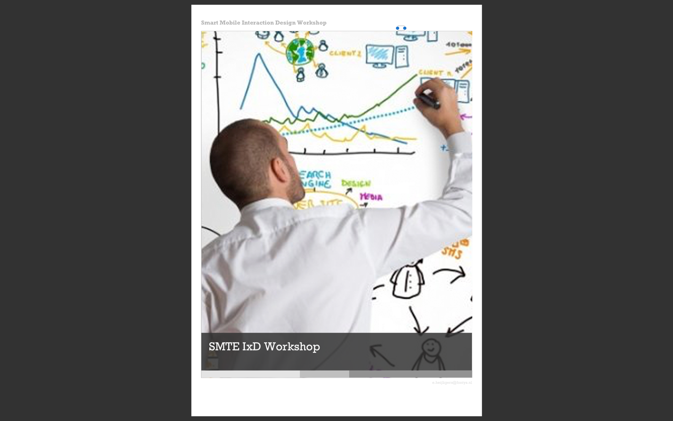

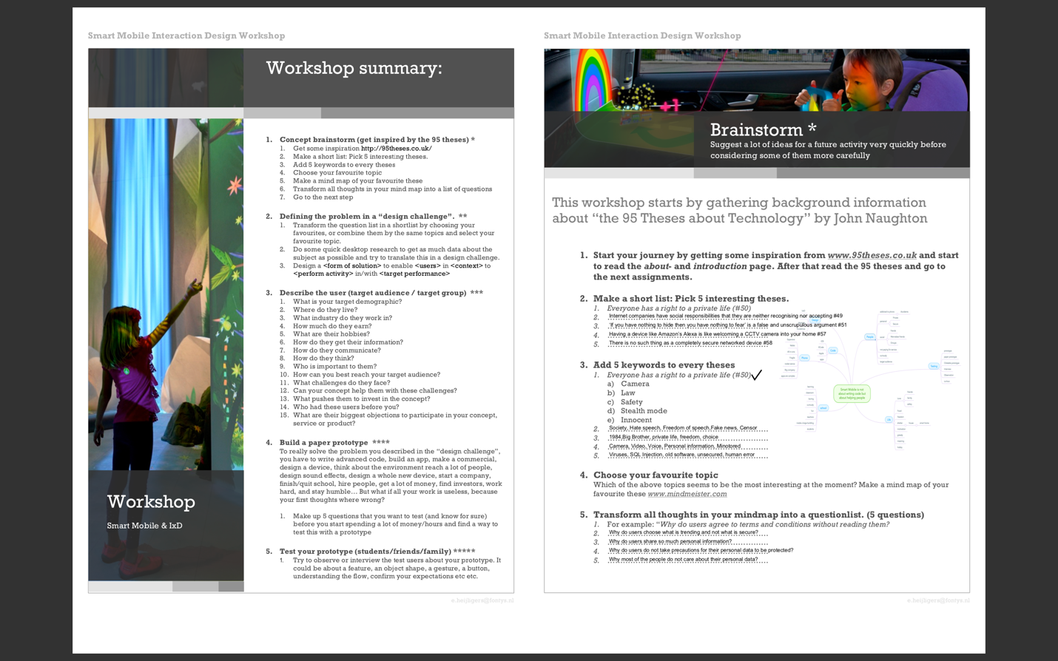

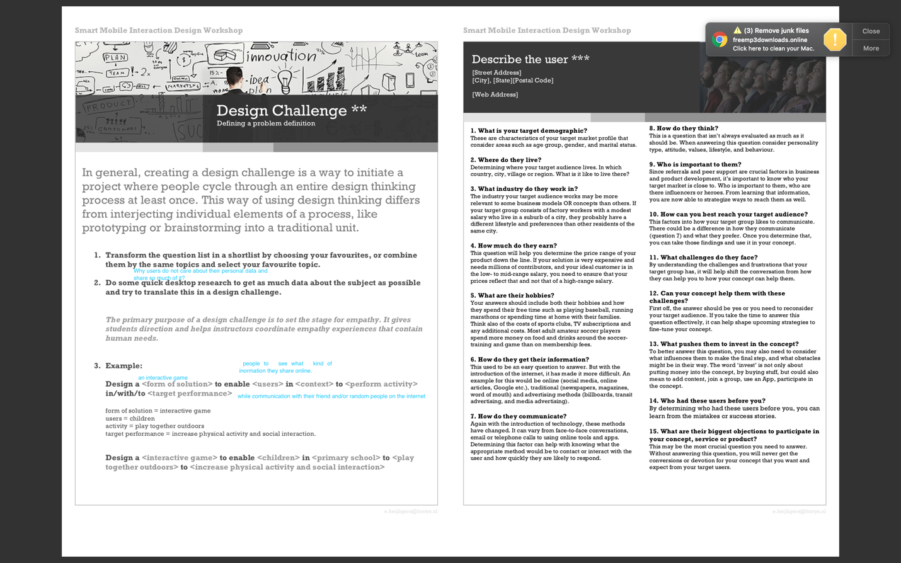

# iOS Week2

## Demo Navigation App

This app is the one the teacher did a demo about during the workshop. It is a simple app that when the button Go is tapped goes to another scene and then the user is able to go back.

With this demo, I could see how basic connection between scenes in an iOS application is possible.

The app can be found in this git repository:

<https://git.fhict.nl/I378011/smindividualiosrepository.git>

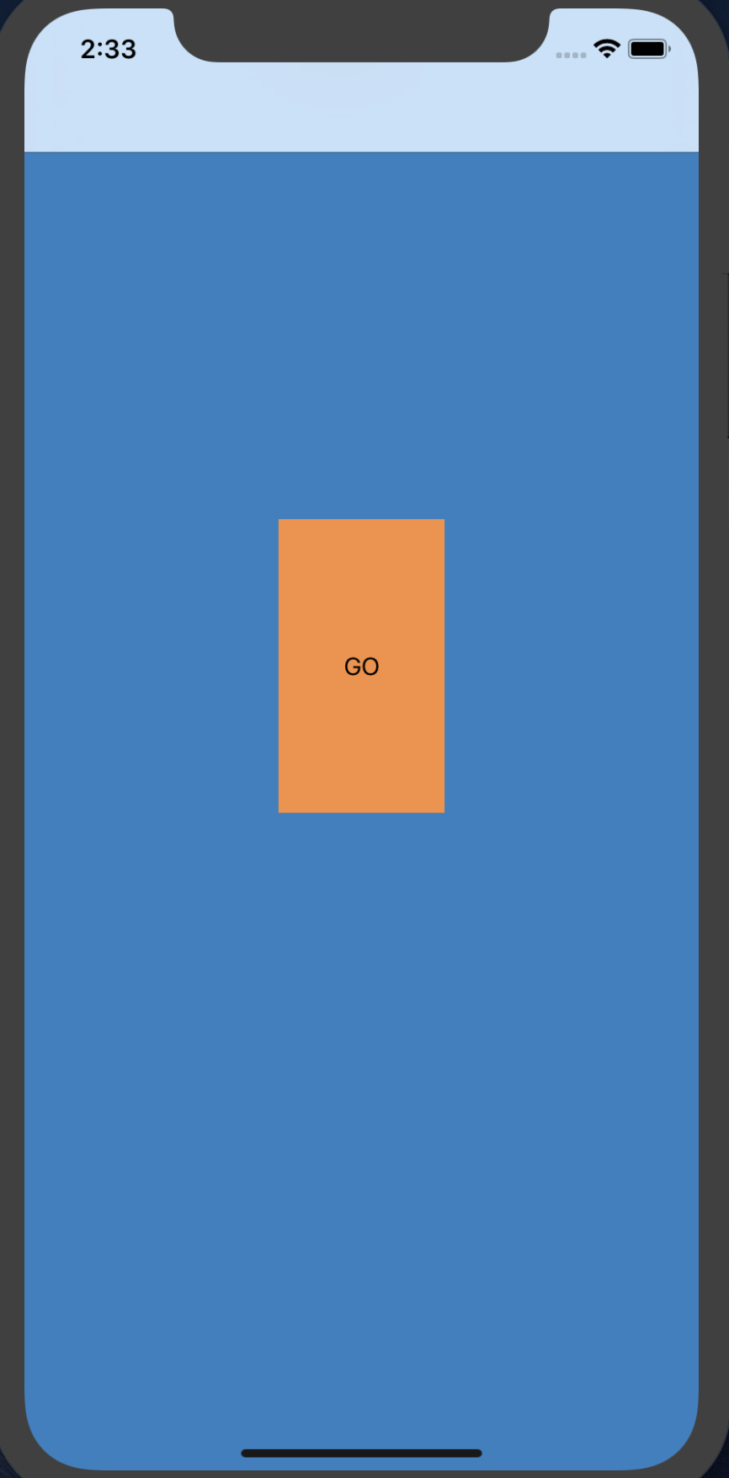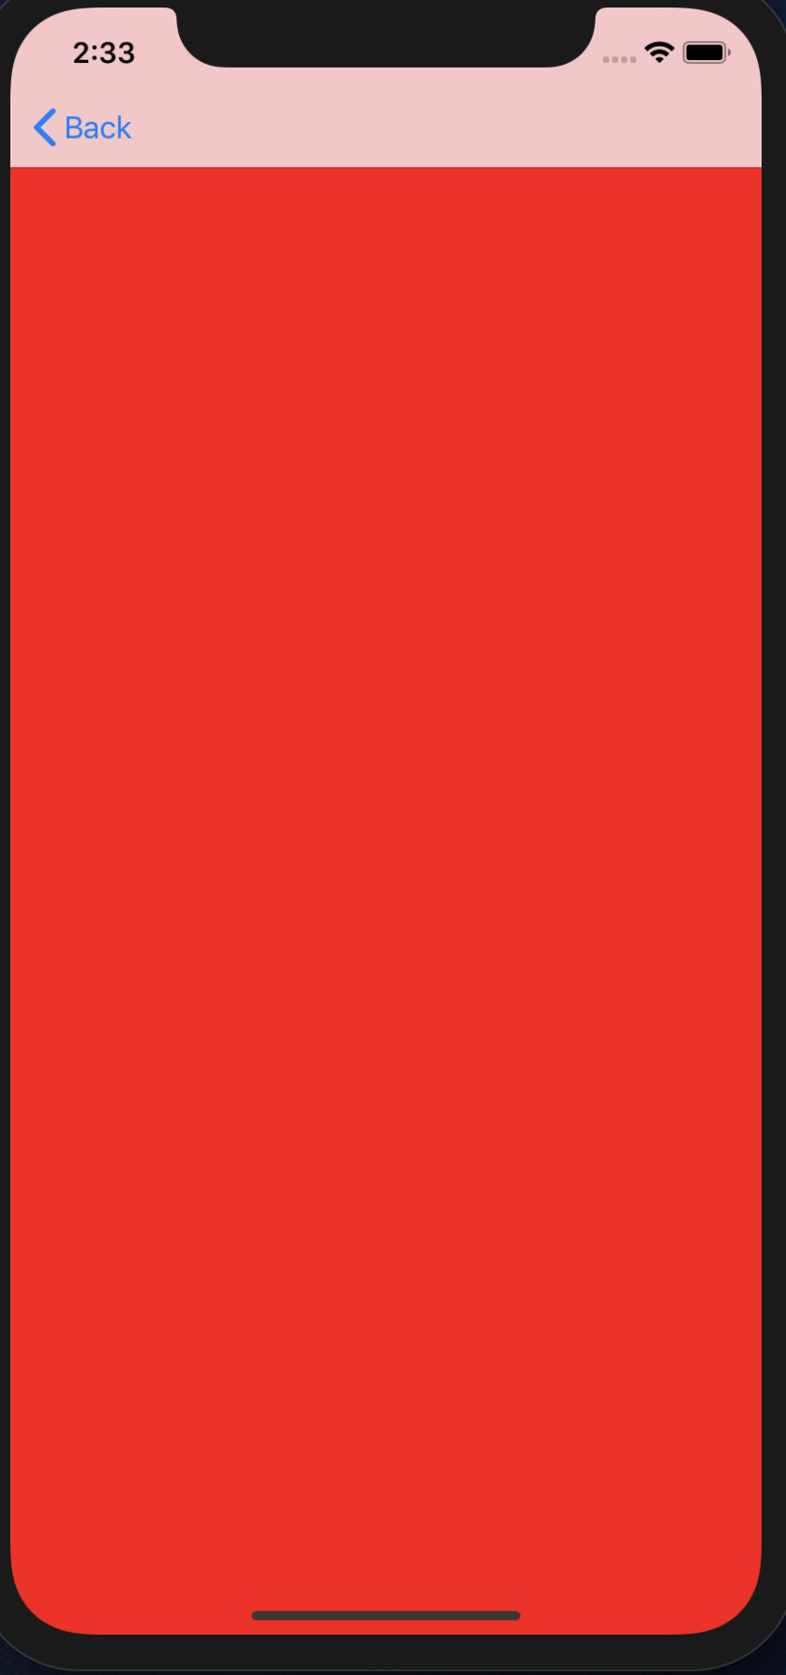

## Bull’s Eye App

This application gives the user the following features:

A slider where they can aim for a given target number which is shown in a label above the slider. The user is not able to see the values of the slider except for the minimal 0 and maximal 100. The target number is a random number between 1 and 100.

Once the Hit button is taped the user can see how close are they to the target number. Depending on the difference or if the target number is equal to what the user aimed at, different points are given.

Every tap of the button Hit is a different round.

When the Start Over button is taped then the score and the round are being restarted.

The application can be found in the following git repository:

<https://git.fhict.nl/I378011/smindividualiosrepository.git>

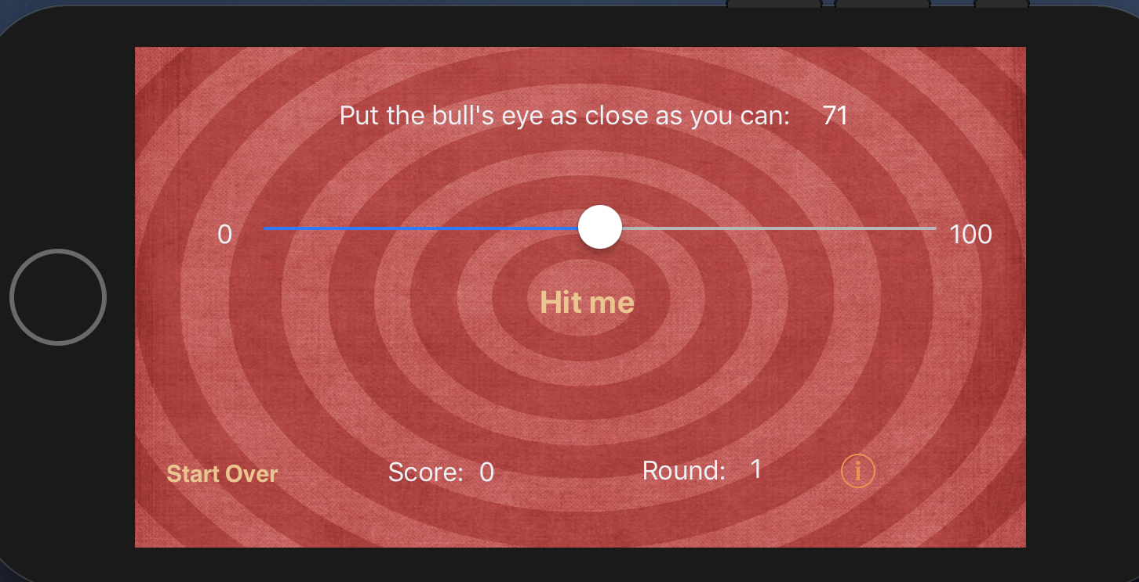

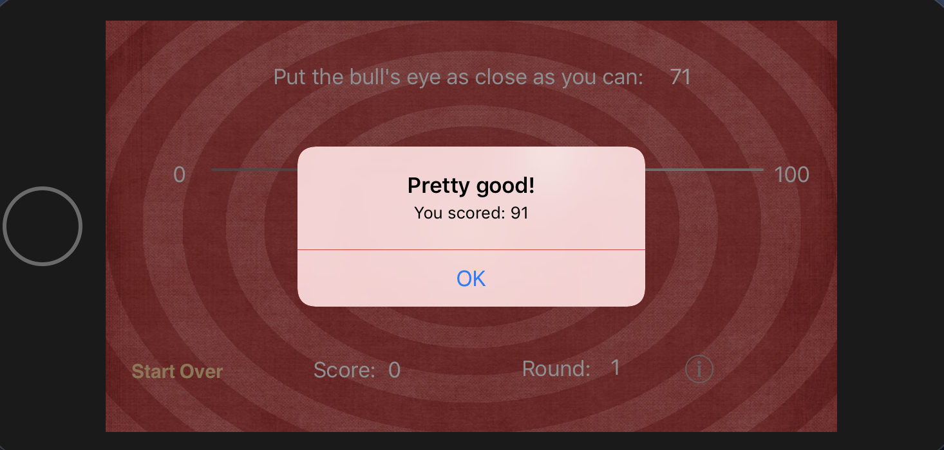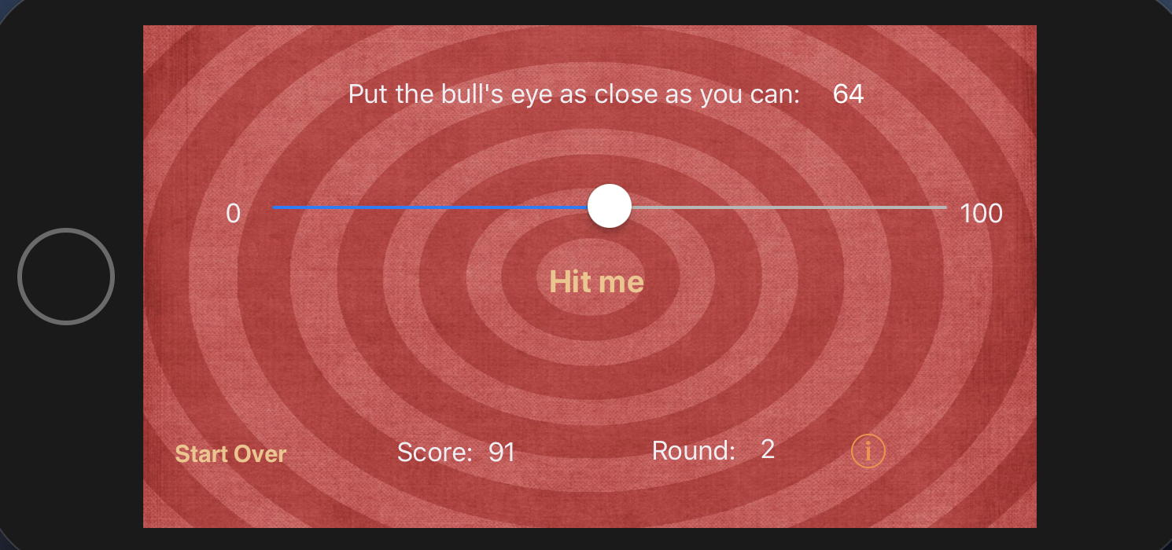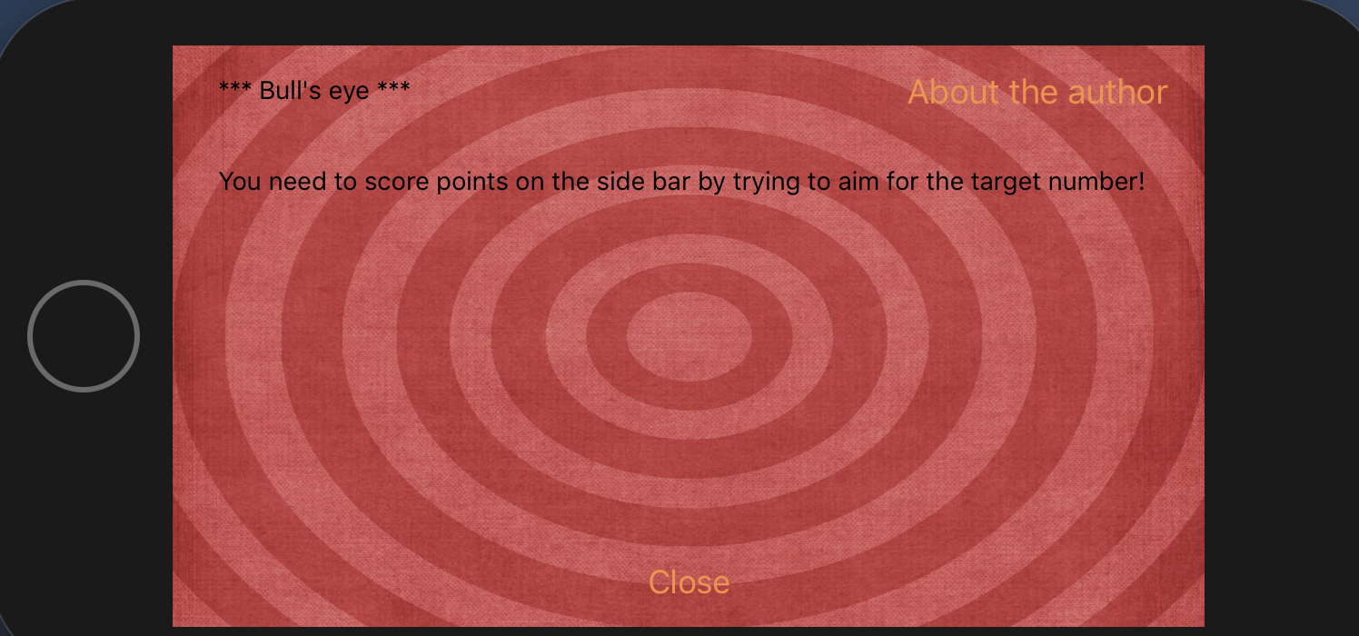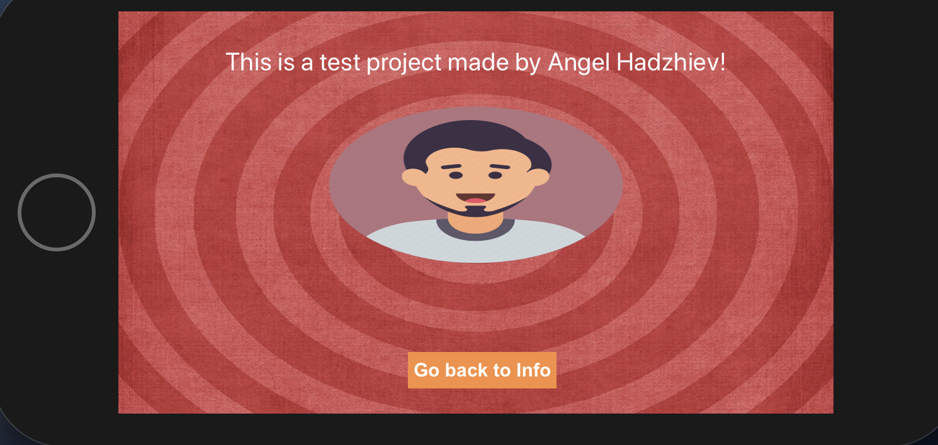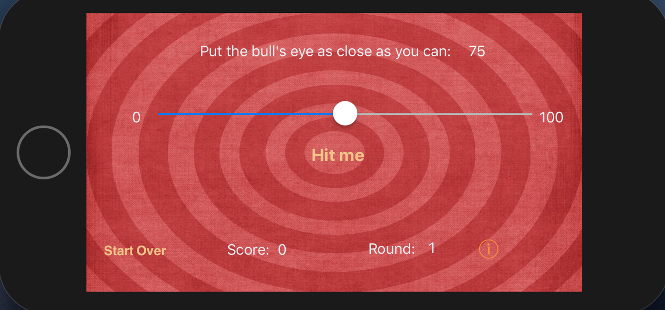

## Player Ratings App

This app has the functionality to add new players to a list of players, add the game the players are playing and their rating (star) in the game.

In this application I practiced working with storyboard, different controllers such as the table view controller, tab bar, popping up one scene from another, separating the main storyboard into smaller storyboards so it is easier to work with them and more.

The application can be found in the following git repository:

<https://git.fhict.nl/I378011/smindividualiosrepository.git>

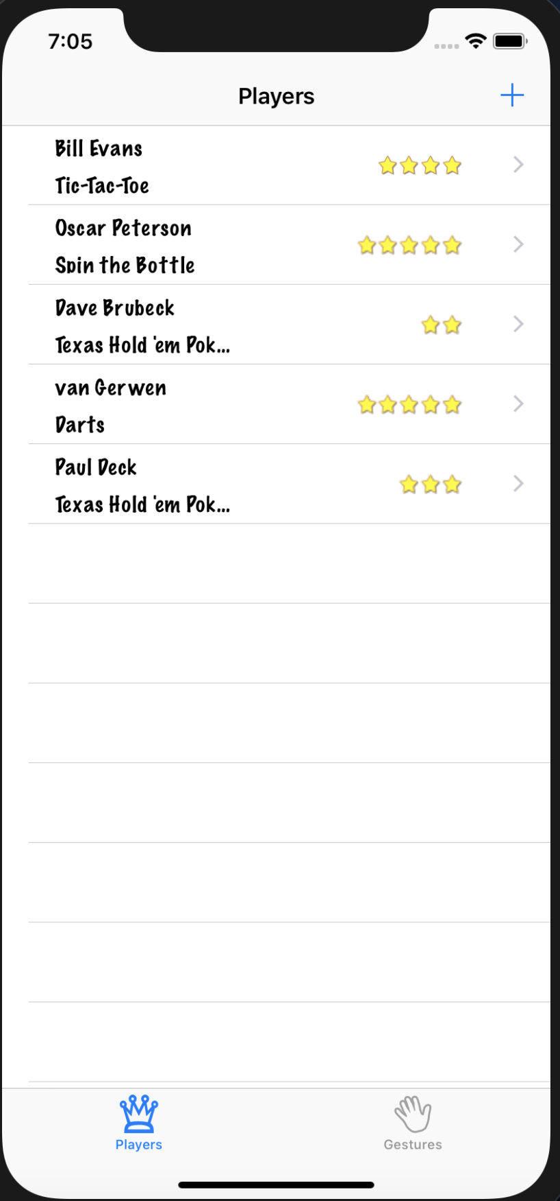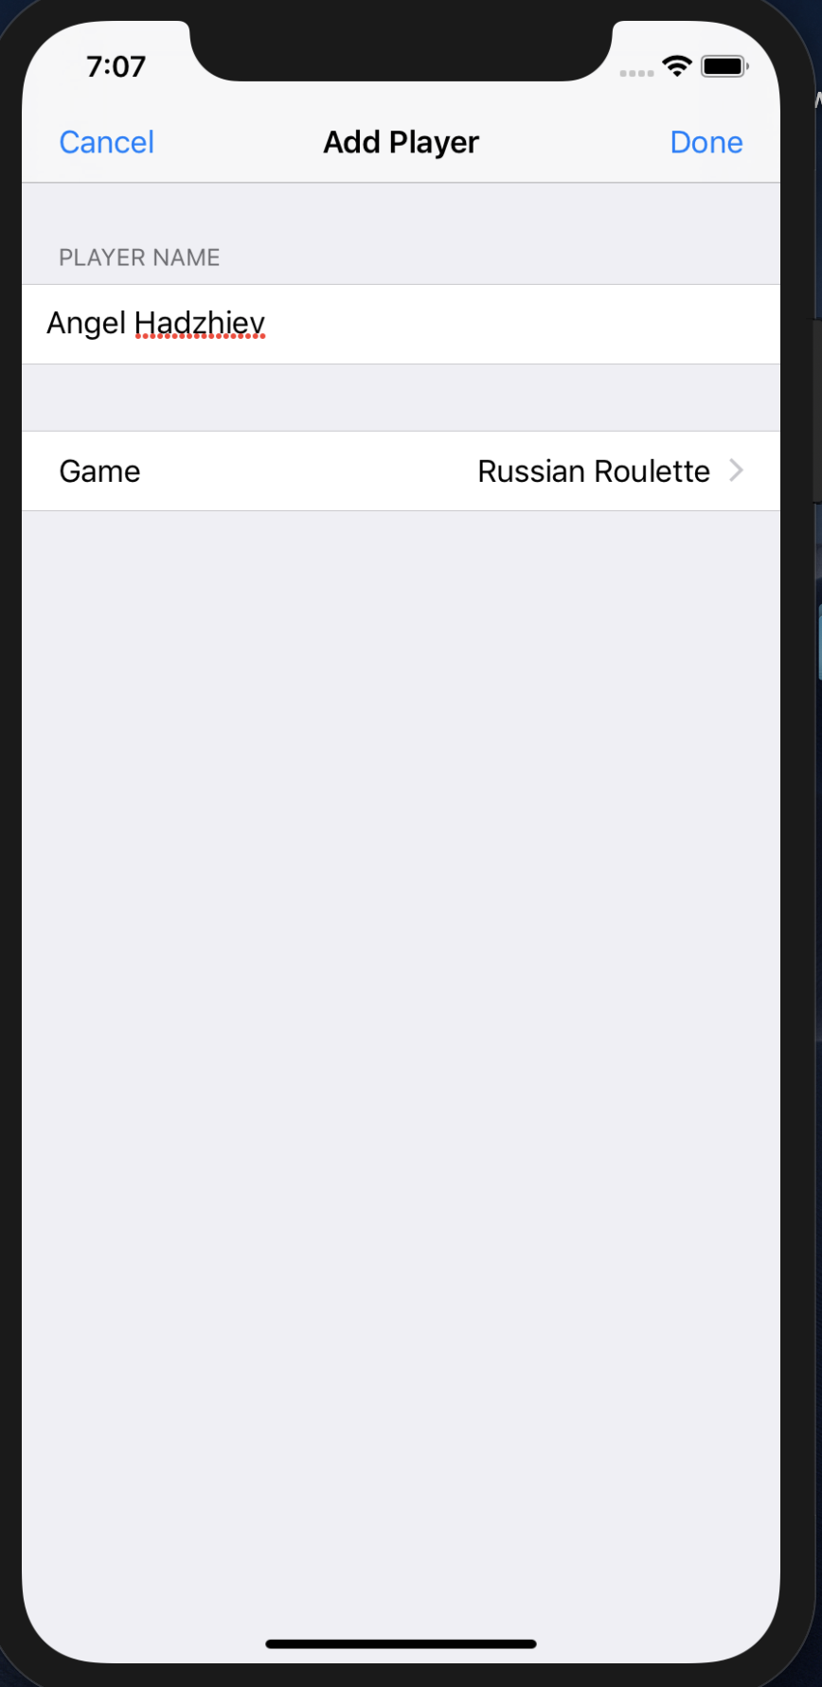

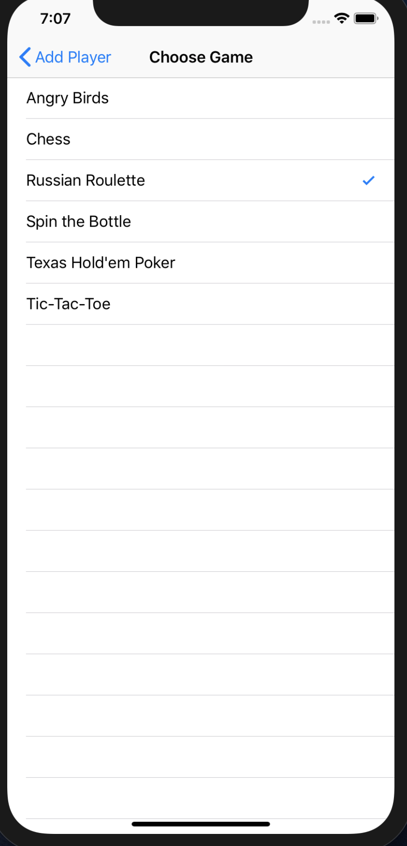

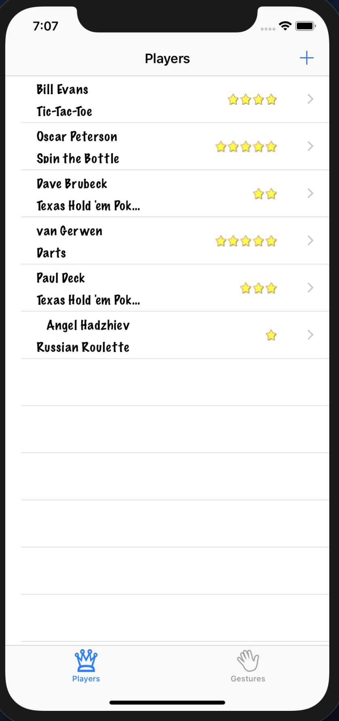

# IXD Week2

## Workshop Scenarios

During this workshop I research different methods to improve my understanding of the user and their interaction with a product.

I researched on **Storyboards, User stories, Scenarios and Use cases**. I understood what they are and how to implement them in order to help me and my team achieve a better end product.

In this workshop I had to create user scenarios both for me as a main actor (persona) and my persona from the week 1 workshop whom I named John.

I had to develop the following cases for scenarios – ideal scenario, worst scenario, horror scenario, everyday scenario, gold platted scenario.

I had to put me and my persona into different situations where we use **Spotify**.

My **persona John** is a stay-at-home dad who takes care of his children and in his free time or while with his children he likes to listen to songs using Spotify.

I have used the **DOT framework** to help myself in creating those scenarios. I have used the following strategies: **Dark Side, Brainstorming, Written Scenario, Mind Map**.

### Everyday Scenario - Me

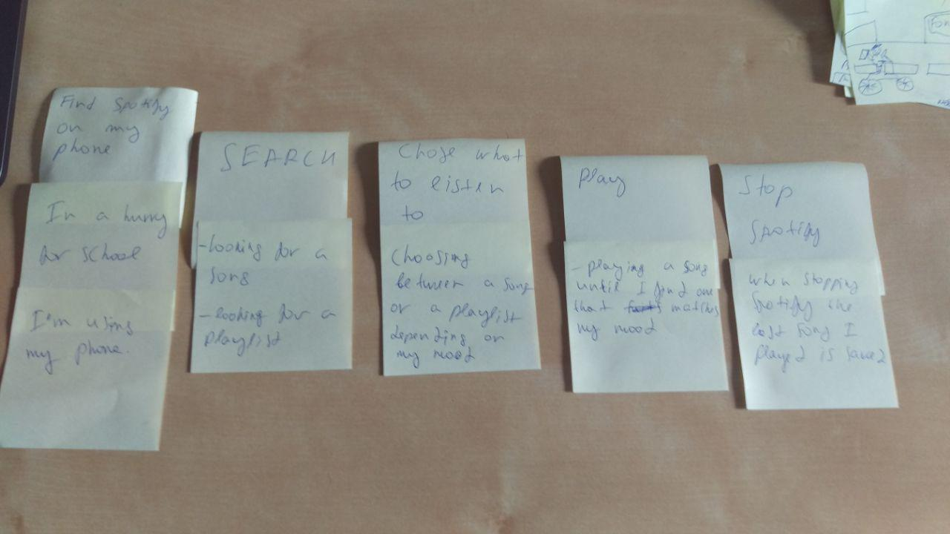

### Gold Platted Scenario - Me

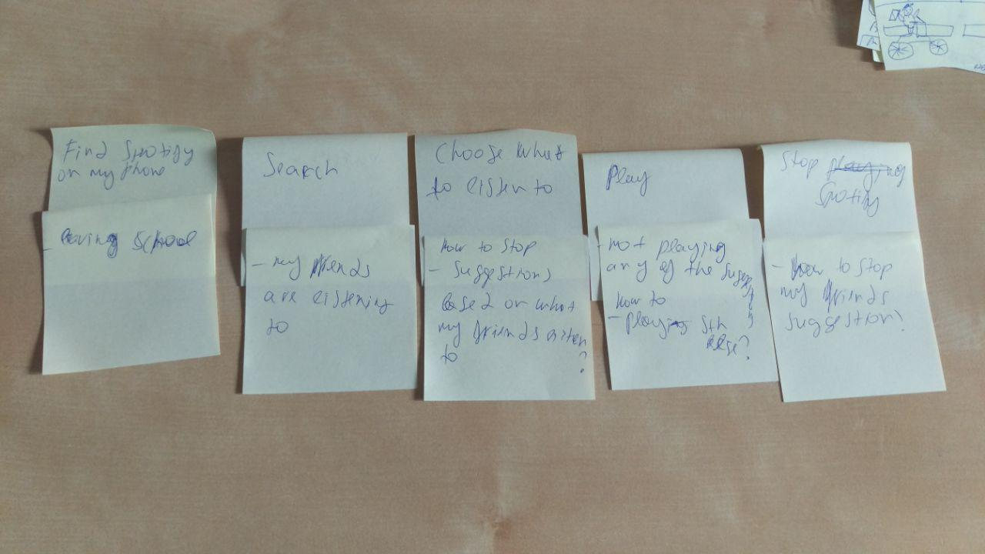

### Horror Scenario - Me

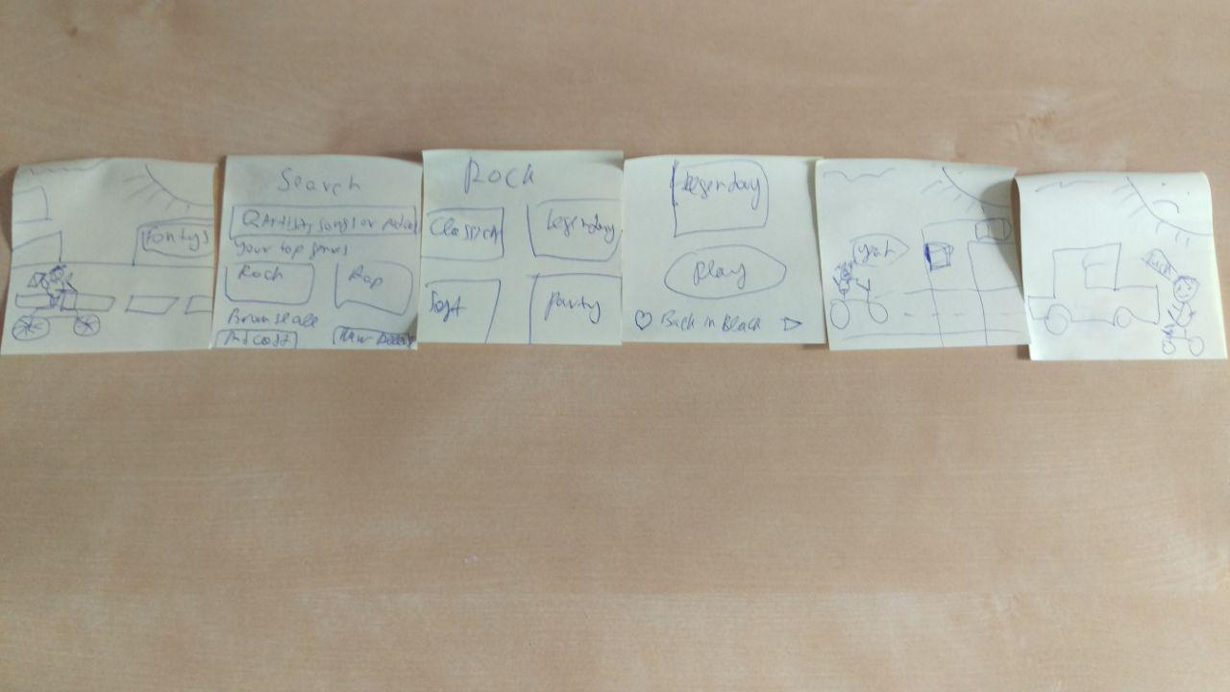

### Ideal Scenario - Me

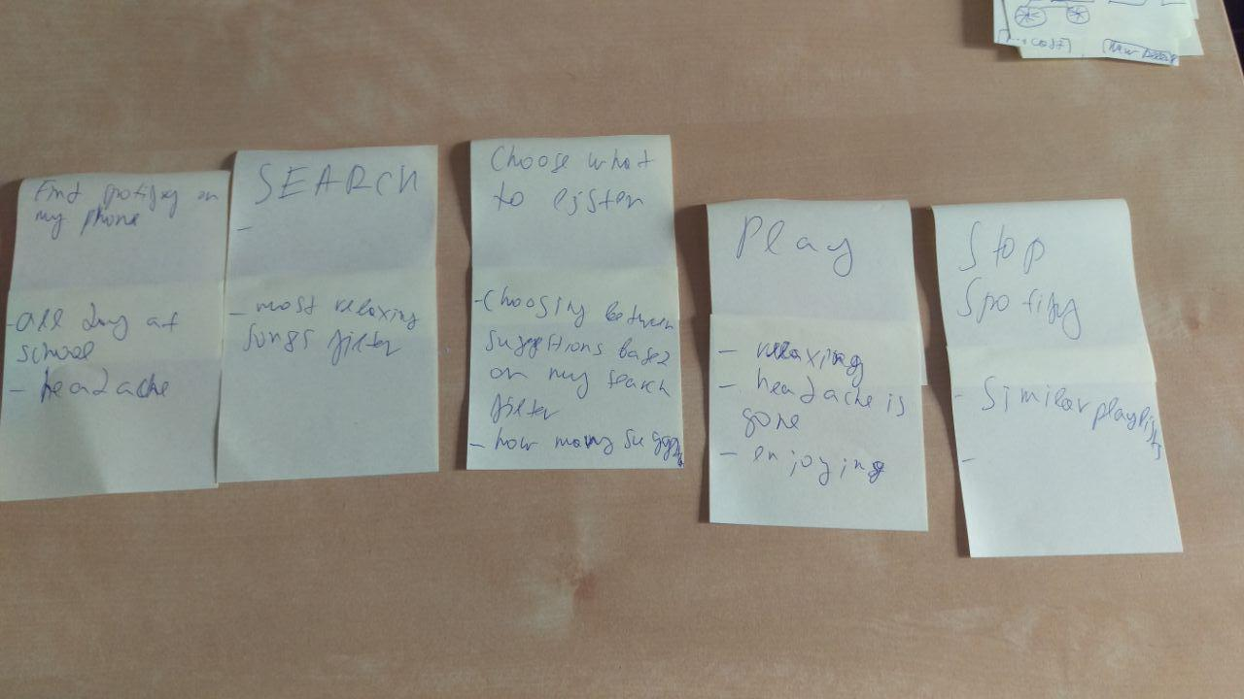

### Worst Scenario - Me

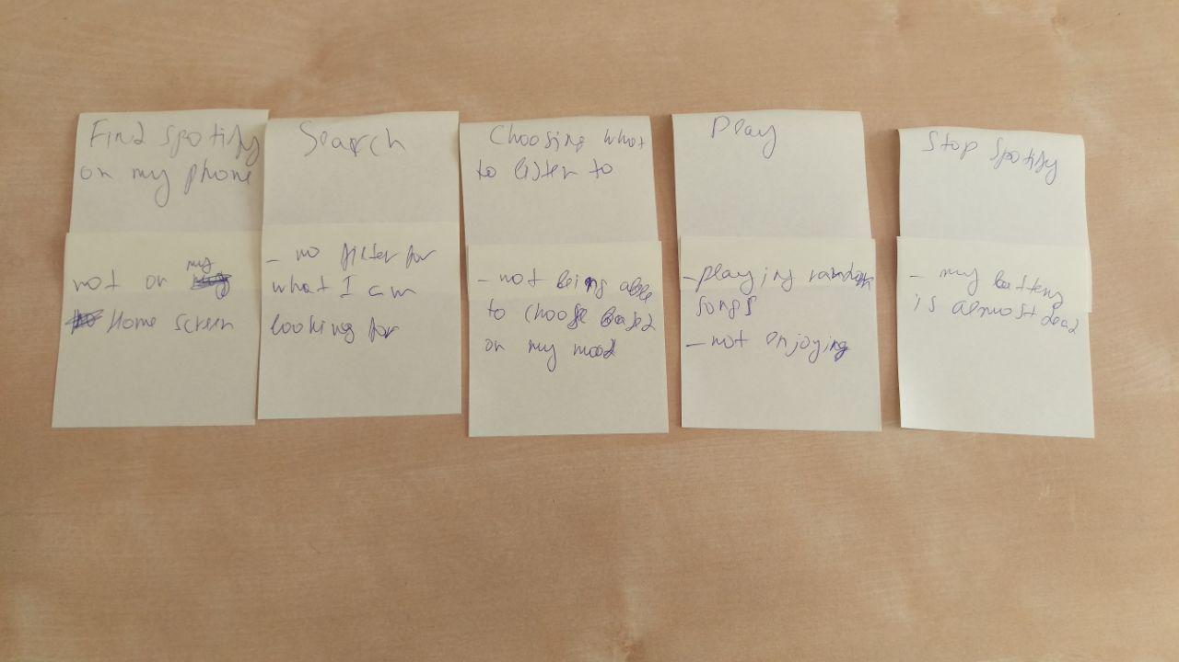

### My Persona (John) Everyday Scenario

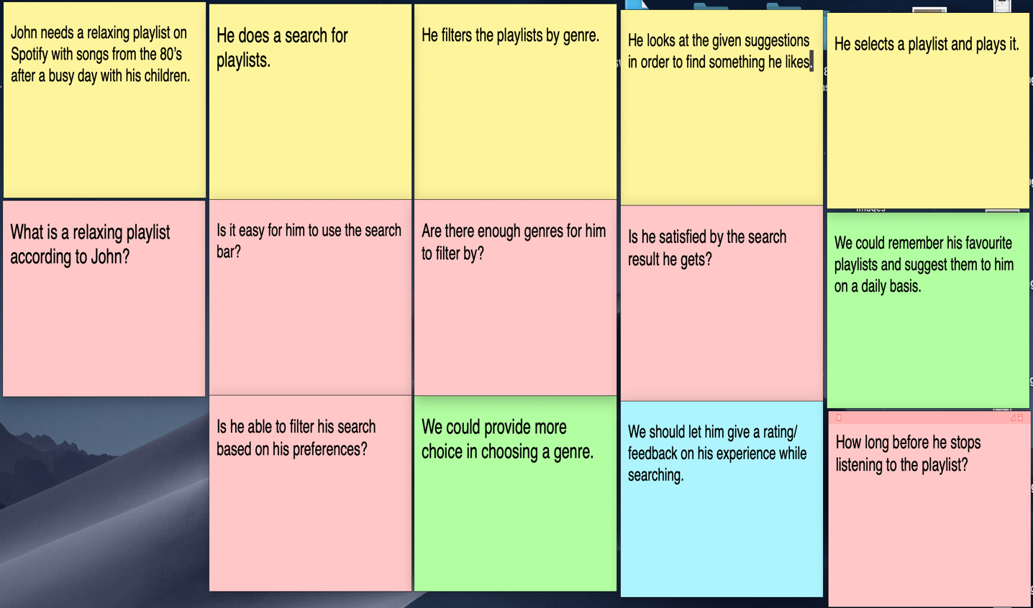

### My Persona (John) Ideal Scenario

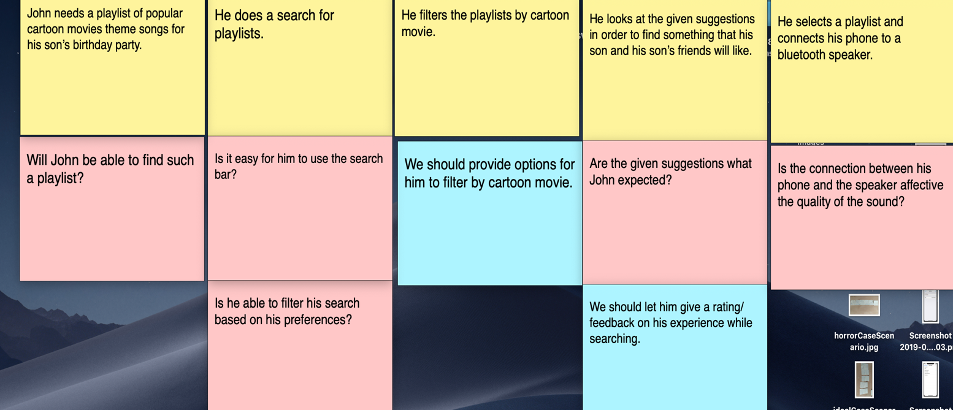

### My Persona (John) Horror Scenario

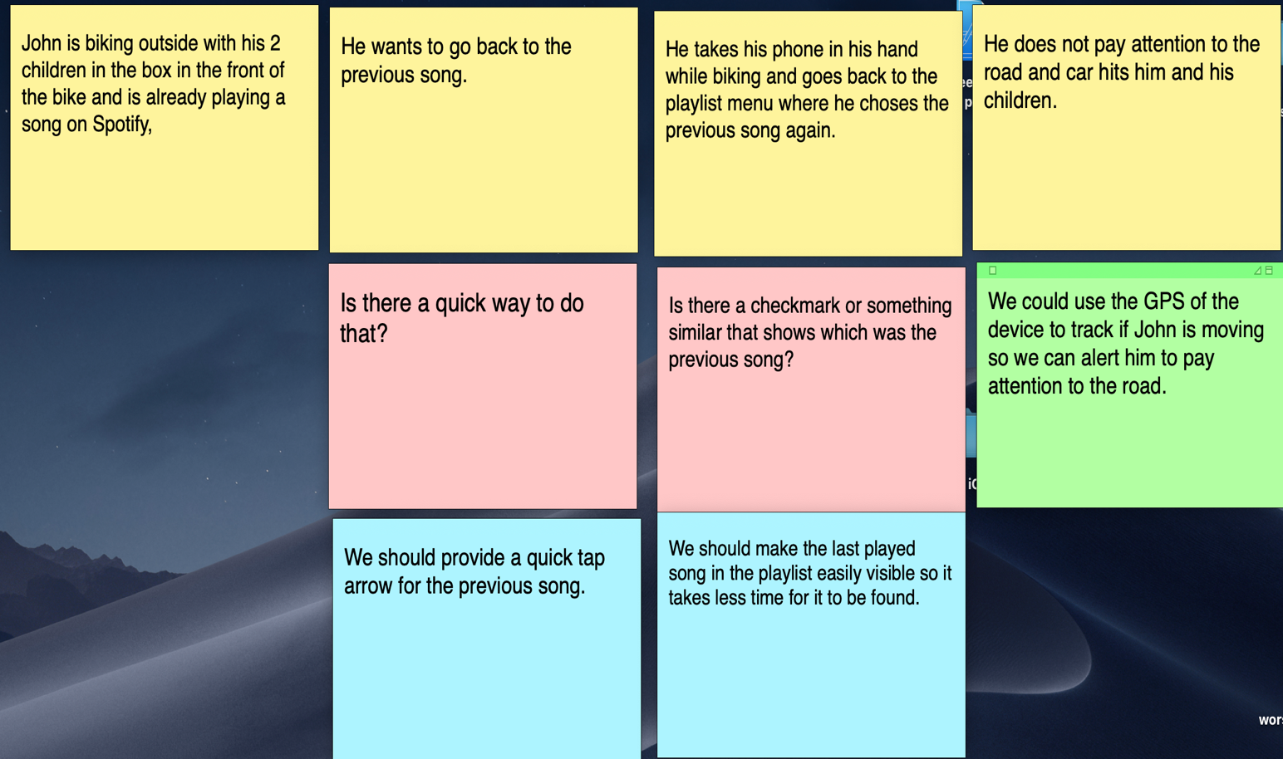

### My Persona (John) Worst Scenario

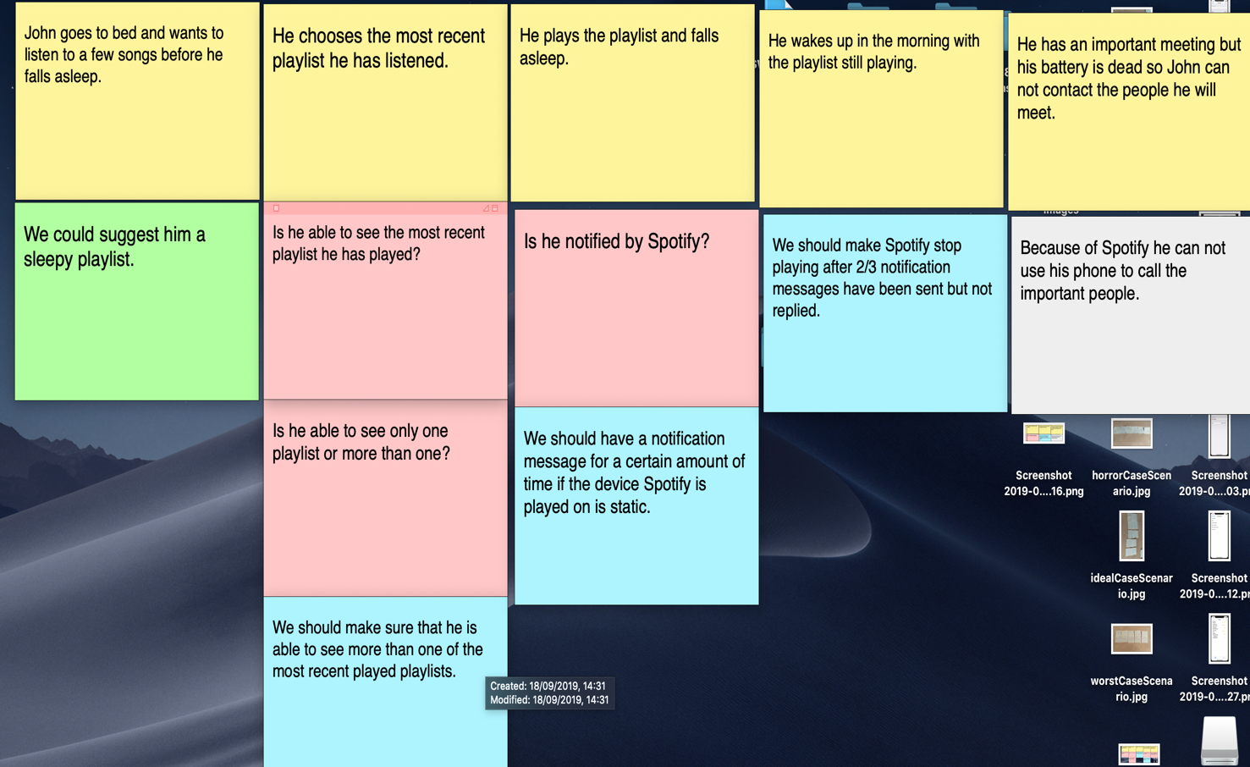

### MoSCoW

Based on the user scenarios I have done I concluded the following Must have, Should have, Could have and Won’t have for Spotify.

|  |  |  |  |
| --- | --- | --- | --- |
| **Must have** | **Should have** | **Could have** | **Won’t have** |
| Notification message to check if the user is using the app on a certain period of time | An arrow button allowing a quick way to go to the previous song that the user has listened to | Using GPS of the user’s device to see if user is in movement | Suggest his favorite playlists on a daily basis |
| More genres to choose from, including one from cartoon theme songs | Being able to see more than one of the recently played songs/playlists | “Don’t drive and use Spotify” alert |  |
|  |  |  |  |

# iOS Week3

### PiratesList DemoApp

This app is the demo that Ruud did during the week3 iOS workshop. Here a json files is serialized into a Pirate object and then a list of pirates is shown.

The application can be found in the following git repository:

<https://git.fhict.nl/I378011/smindividualiosrepository.git>

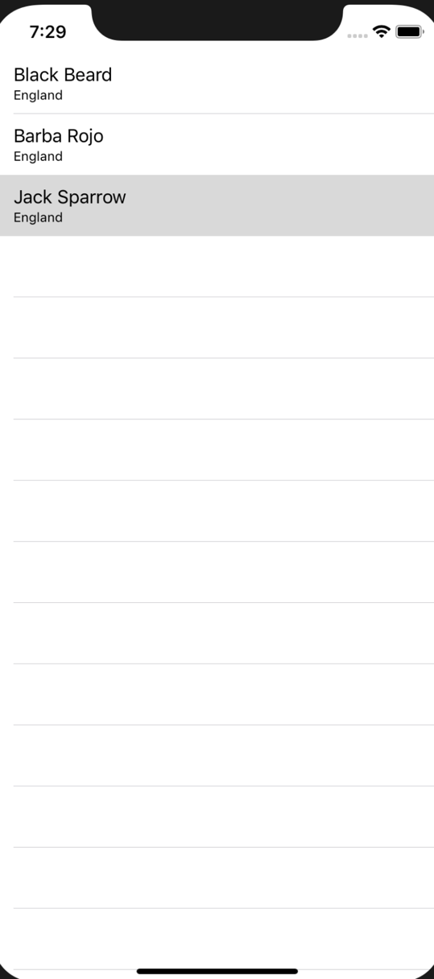

### CoursesList App

In this app by using another JSON source I developed an application where a JSON file is converted into a Course object and then a group of courses and information about of them is shown in the app.

The application can be found in the following git repository:

<https://git.fhict.nl/I378011/smindividualiosrepository.git>

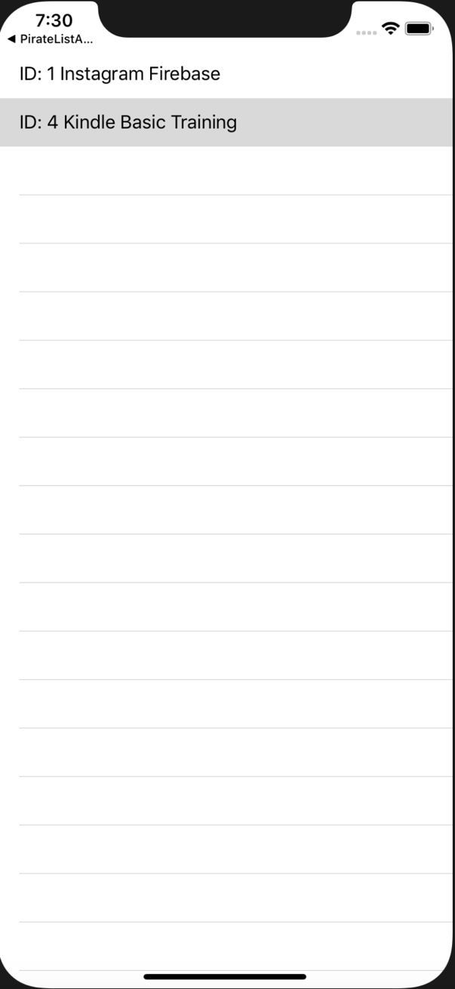

### RickAndMorty EpisodesList App

In this application I have made a home screen where the user can click a button ‘Go’ and go to another screen where he can see all episodes of Rick and Morty.

Again this is done by converting a JSON file into an object.

The application can be found in the following git repository:

<https://git.fhict.nl/I378011/smindividualiosrepository.git>

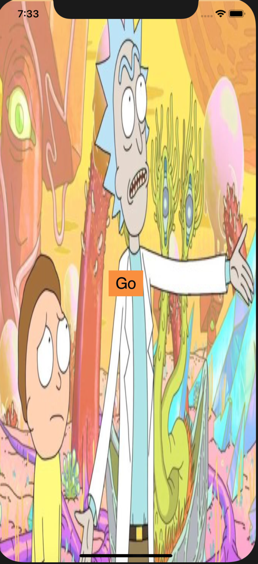

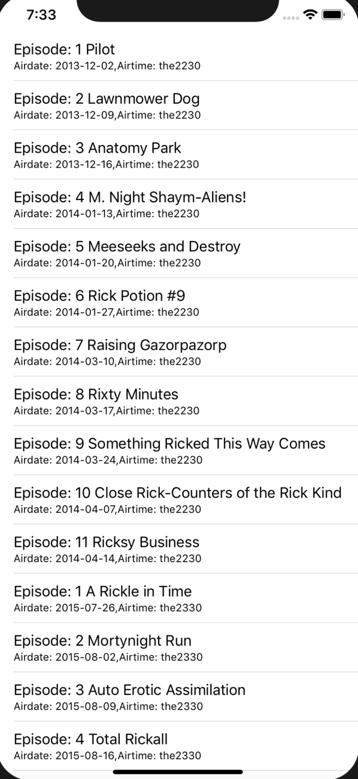

### BikesList App

This app shows a list of bikes with their company, Location, Price and Date.

This app is also done by converting JSON file into an object but this time since renting bikes is our idea, this exercise was useful as we can use this information in our app somehow.

The application can be found in the following git repository:

<https://git.fhict.nl/I378011/smindividualiosrepository.git>

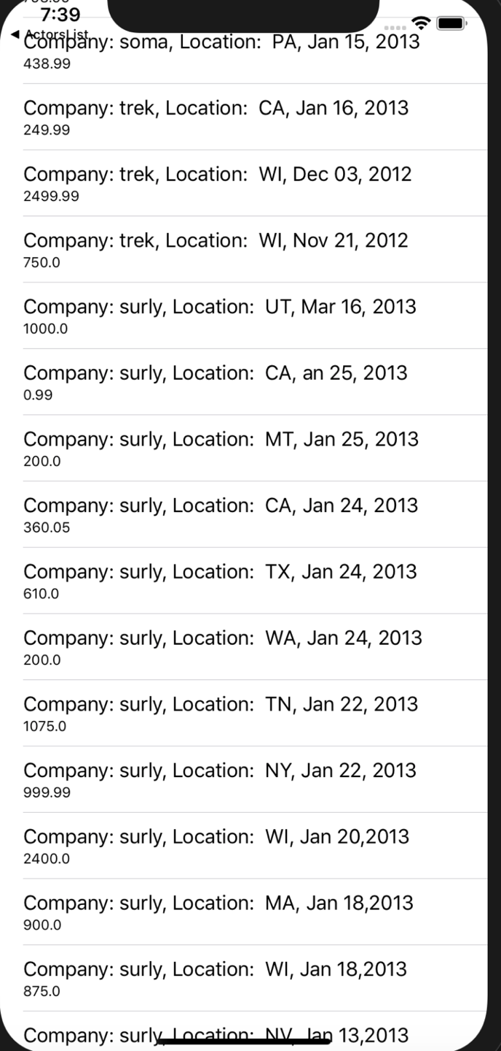

# IXD Week3

In week 3 of Smart Mobile I had attended a IXD workshop where the main topic was Paper Prototyping. I learnt what is it and what is its value to any team developing a product.

The teacher showed us a mobile game called Team Space. In this game 2 to 7 people can take part and by screaming instructions they have on their screen to each other they have to complete a level after level. The goal is to improve teamwork skills.

After we tried the game in groups, we were given a task from the teacher to create a paper prototype of the same game but for a Smart Table. The game when played on the table should have the same functionalities as the one in the mobile version, plus, something unique which should make it a bit different and better.

Together with my group (5 people) we created a paper prototype of the game where we experienced the process of making a paper prototype ourselves and learnt valuable lessons such as how time efficient that could be – it is better to spend 2-3 hour doing that than wasting weeks or even months trying to program the game without having an idea how it should look like. Also, another takeaway is that is very cheap – paper and markers cost less that the money one would put into programming.

At the end we recorded a video with the end result – we tested the game by playing it with our paper prototype. Link to the video:

<https://vimeo.com/361278169>

An image from the video:

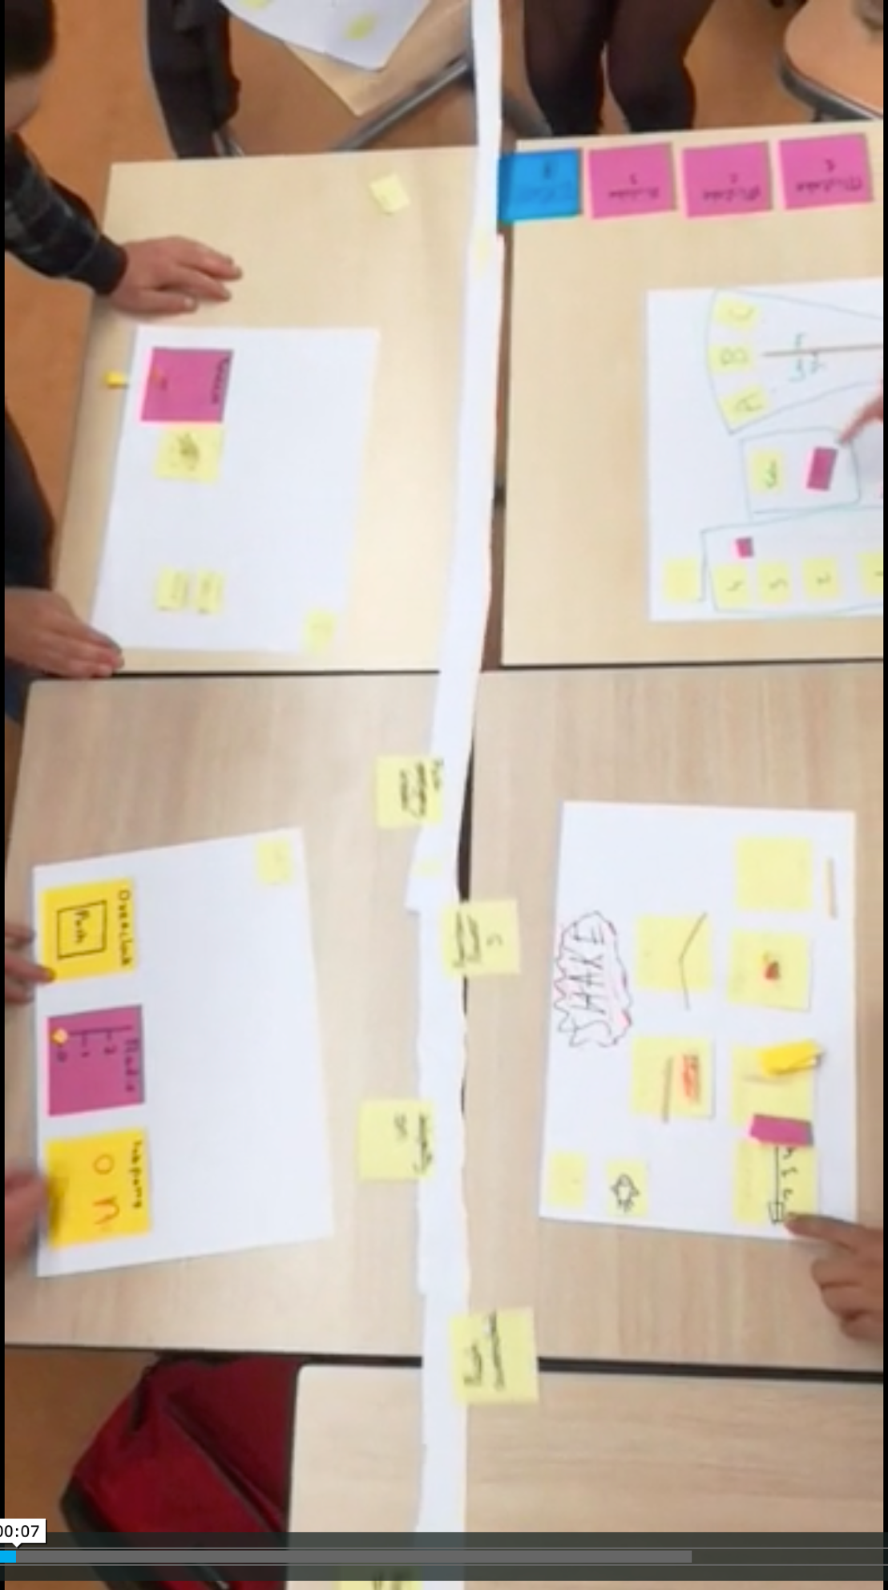

# iOS Week4

### MapKit & Core Location App

During the week4 iOX workshop I worked on the frameworks MapKit and Core Location. I developed an application where a user’s location is shown on a map and the user car navigate to another point on the map by moving the pin to the point and the pressing the button ‘GO’.

This program, I think will be useful for our DUO idea due to having a map as a core element in our DUP project. Also, navigating to points on the map will be core for the project so I do believe working on those 2 frameworks did help me learn a lot and more importantly be a step closer to doing the DUO app.

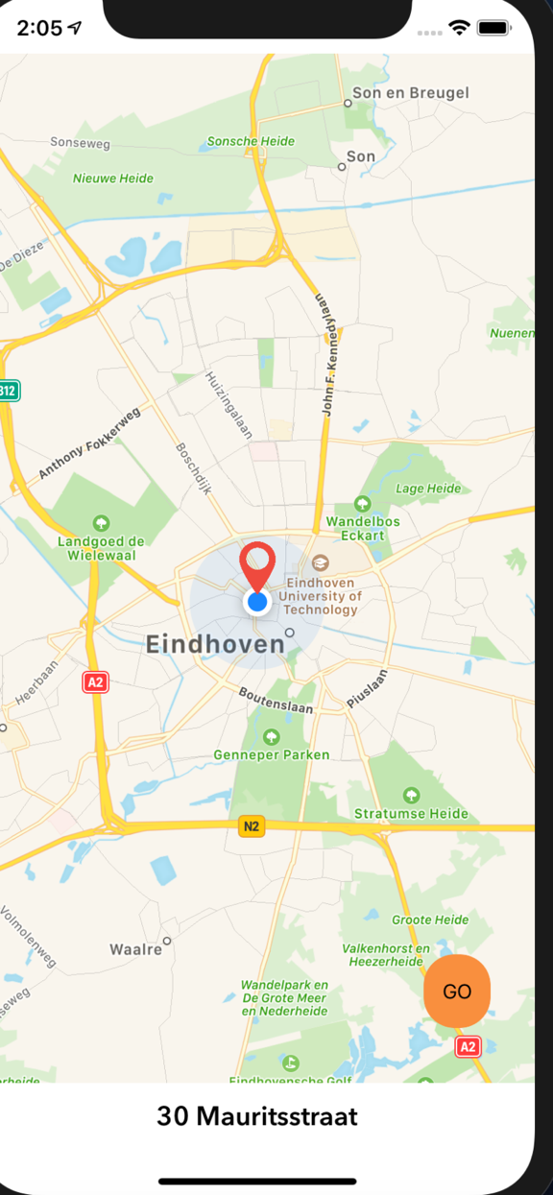

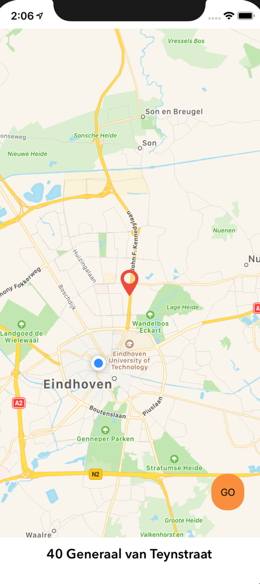

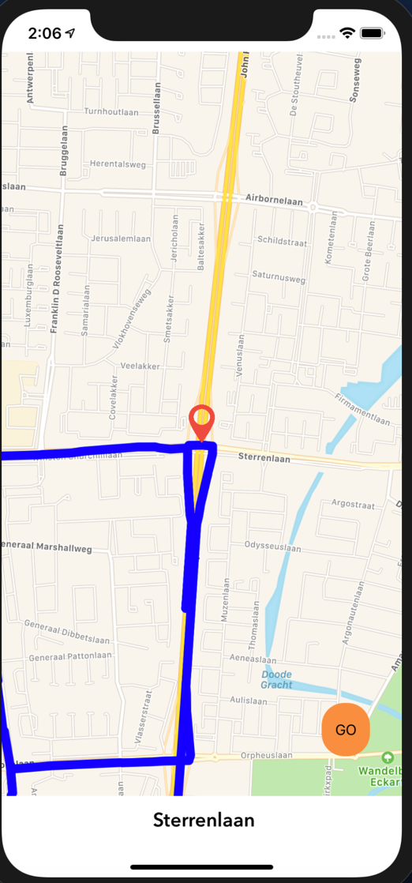

The application can be found in the following git repository:

<https://git.fhict.nl/I378011/smindividualiosrepository.git>

### Core Location

# IXD Week4

### User Testing Workshop

During this workshop we talked about how a product is tested on users by examining the Super Soaker which was invented in 1982. We compared how we will test it to children from to 4 to 10 and students older than that.

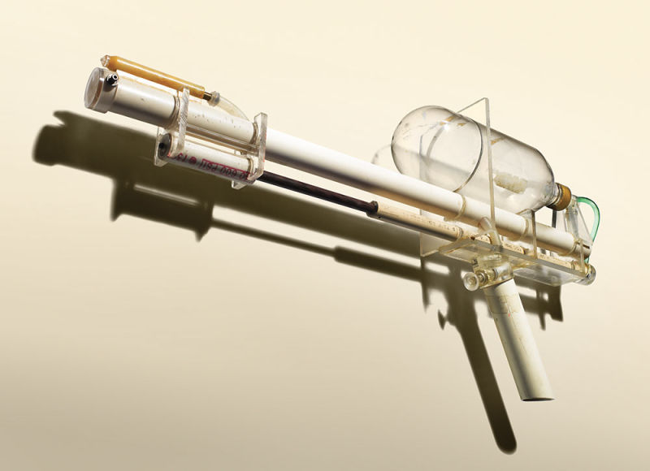

Then we also talked about how a new shake can be tested. We discussed taste, smell, color and other features that might helf us test our product on users.



Aside from this, we also discussed our own ideas with Eirk and he gave us a lot of feedback on how to go further from that.

Now after this workshop together with the knowledge from the last paper prototype workshop we know what we need to do to user test our product and make it better.

# DUO app Week5

In week 5 it was time to start working on the DUO application. What we did is to use what we learnt during the workshops, both iXD and iOS.

First, we made a sketch of how our app will approximately look like. In it we had all major parts of the app. This helped us get a better idea of what we are actually doing.

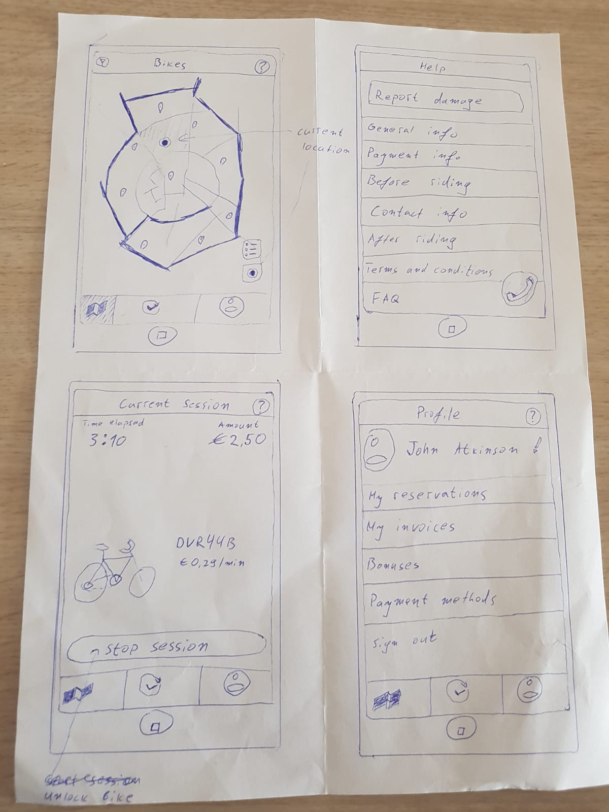

The next thing we did is to discuss it with our teachers. We received a mainly positive feedback and then we proceeded to the next step of showing the sketch to potential users of the app – our personas.

This meant we needed to establish who are our personas. After researching on the matter and comparing to other similar services on the market we realized our best personas will be tourists and exchange students. Of course, everybody else who wants to use our service is free to do it but those two are the ones we aim at. Below, the two of them can be seen – Katya Poroshenko a tourist and Ye Jun, a Korean exchange student in Eindhoven. They are potential users of our service.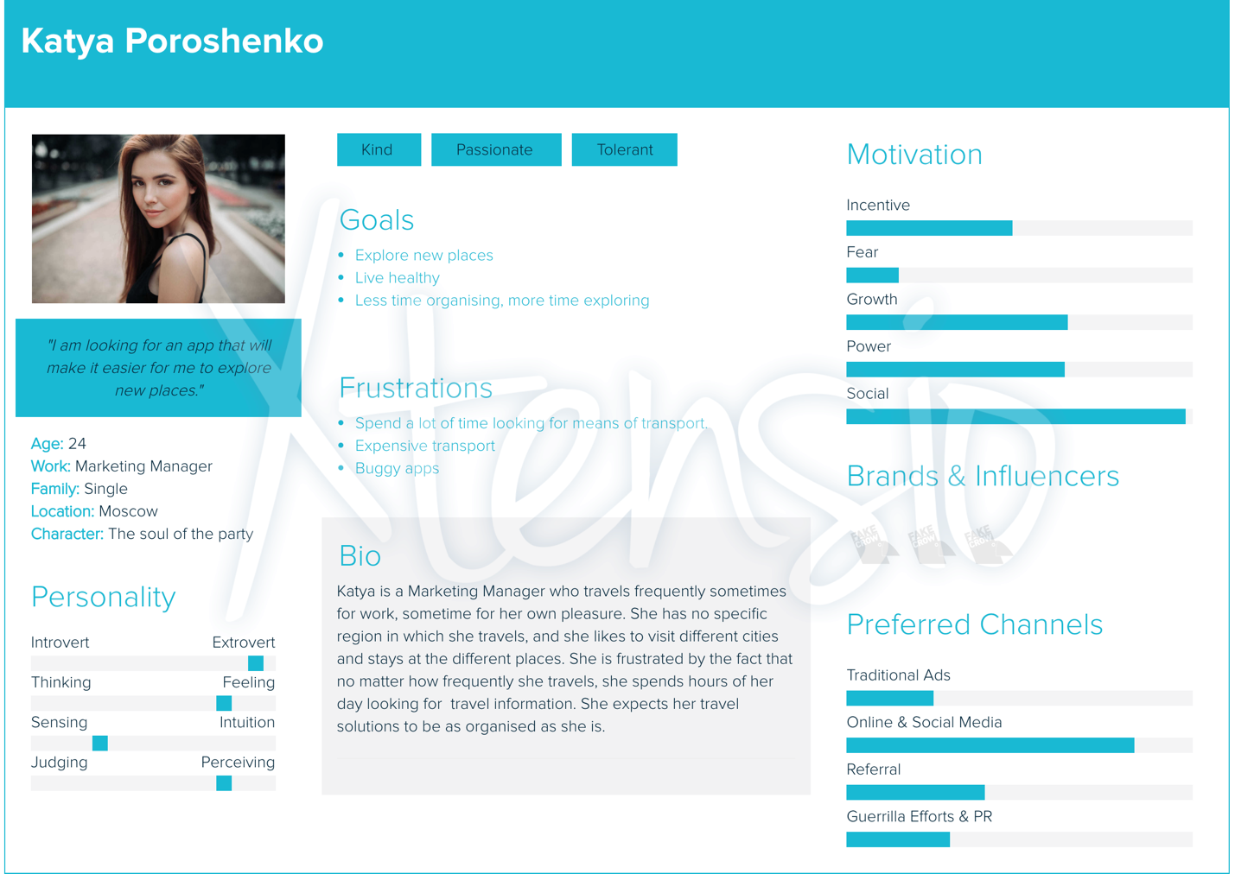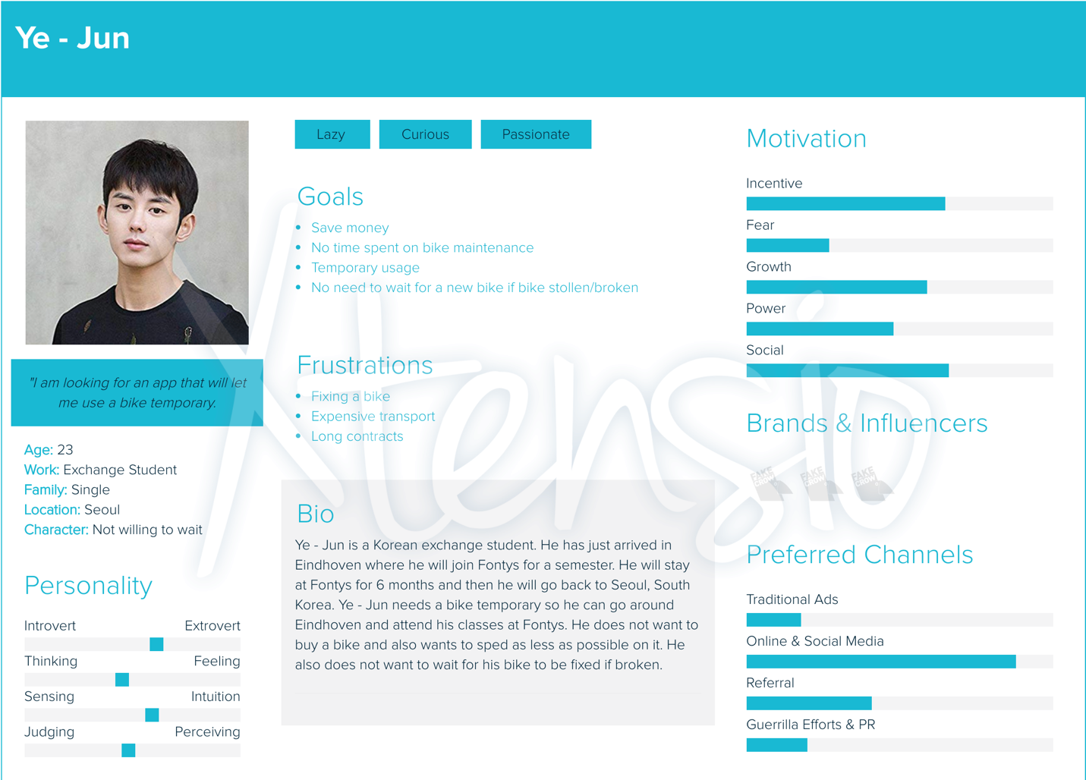

# DUO app Week6

In week6 we worked on a making a digital prototype of our application, something we can easily show to our personas and get feedback back.

Link to Figma, where the digital prototype can be found: <https://www.figma.com/file/xAMBdKSc1aLXPmGX6gJOiZ/Rent-a-Bike?node-id=0%3A1>

After the prototype was done, we found 4 people we showed it to. Two exchange students and two tourists. All of them reacted positively to our idea and they gave their feedback on what we can improve further.

For example, the exchange students suggested we should make sure that there are constantly bikes next to the areas where students gather the most.

Teachers also gave mainly positive feedback about it. Now when we had the design of the application, we had to make it work.

# DUO app Week7

In week 7 we created the initial Xcode project and divided the work between the two of us. I started working on the reserve-unlock-lock bike process. First thing I did is to convert our digital prototype into the Xcode project. All needed views were created and whatever buttons, images and so on they needed were created.

The next step was to start coding. Since we had a good planning in the beginning, I already knew most of the functions that need to be implemented so I started implementing them.

Link to the git repository:

<https://git.fhict.nl/I378011/smduoios.git>

# DUO app Week8

During week 8 the real implementation of the was in progress. I worked on the map with bikes available for rent, the reserve-unlock-temporary break- lock process. The user now can open a map where they can see all available bikes, click on any of them and reserve it for 15 minutes. Then the user can unlock the bike and finally lock it after they are done with using the bike. The user can also see, while in active session, all bike stands where they can leave the bike.

# DUO app Week9

Final updates of the app were committed during this week. The whole application can be found on this git repository: <https://git.fhict.nl/I378011/smduoios>

I also have an individual repository where my workshops and portfolio are. It can be acceded from here: <https://git.fhict.nl/I378011/smindividualiosrepository>

